Instructions on How to Make Automated Monthly Donations if You Don’t Have A PayPal Account.
Donations to the Religious of the Sacred Heart of Florence, Italy (Religiose Sacro Cuore di Firenze, Italy) made in U.S. Dollars through the Friends of the Sacred Heart of Florence are processed through PayPal. In order for PayPal to process automated monthly payments, you will need to open a FREE PayPal account which can be done as you make your first monthly subscription. It’s easy, so let’s get started.
1. First select the amount you wish to contribute monthly...
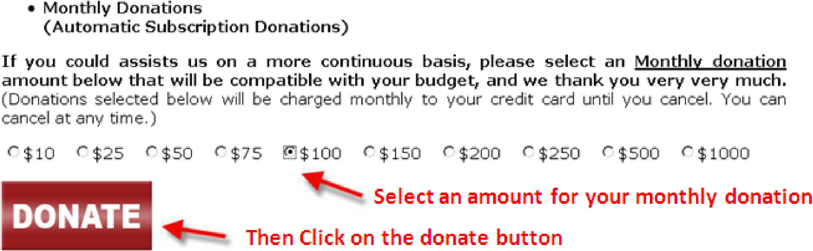
- Then Click on the DONATE button.
- You will be brought to the screen shown below. If you already have a PayPal account, simply log in to your
PayPal account with your PayPal registered email address and password. If you do not have a PayPal account, click on the “Pay using your credit or debit card” link (see below). Then click the Log In button on the lower right of the page.
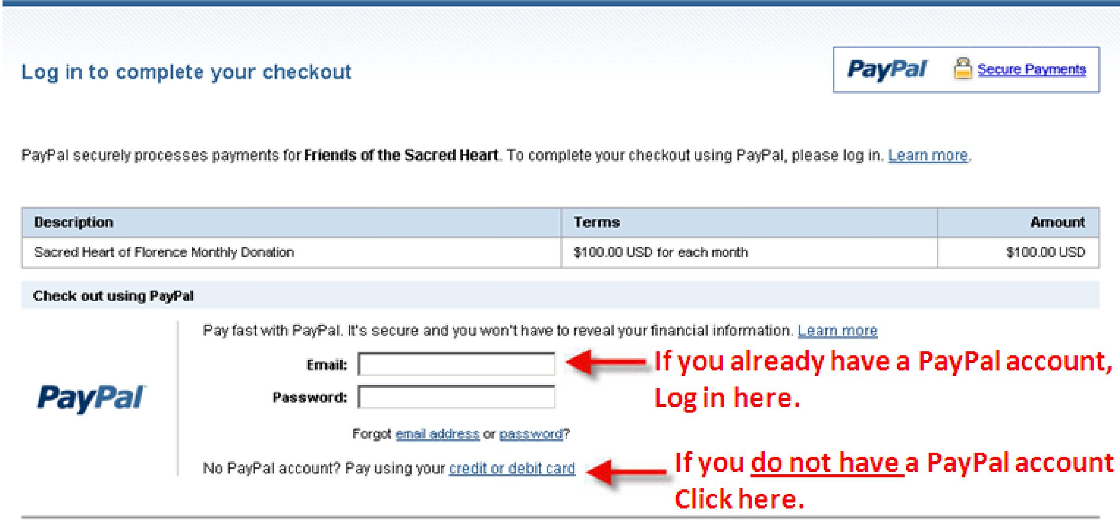
4. Next, you will be taken to the registration page shown below (on the next page). Fill out the form which will
register you with PayPal and create your FREE PayPal account, then fill in the characters at the bottom of the form which help ensure that the form is being filled out by an actual human being instead of an automated system. Then click the “Continue” button on the bottom right side of the page.
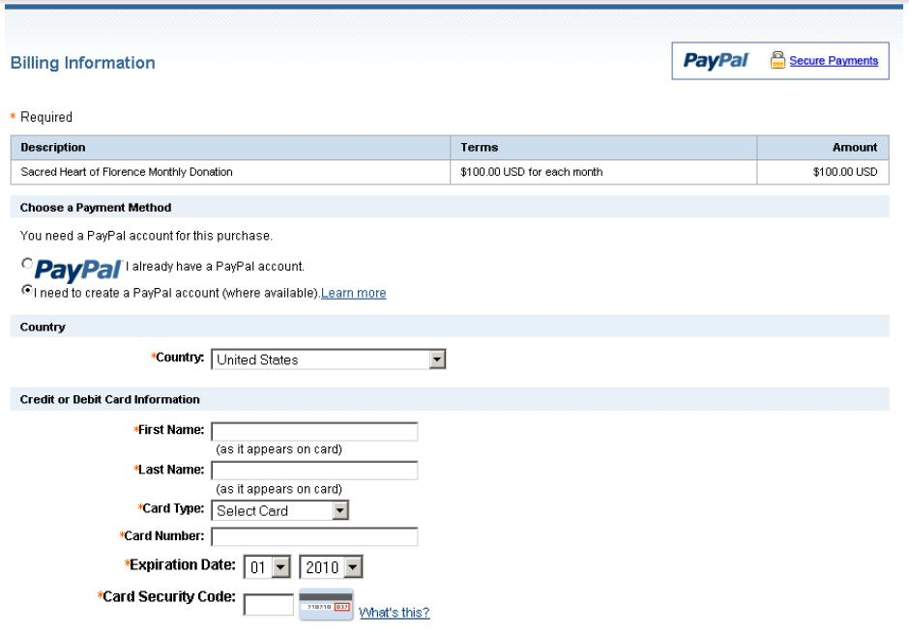

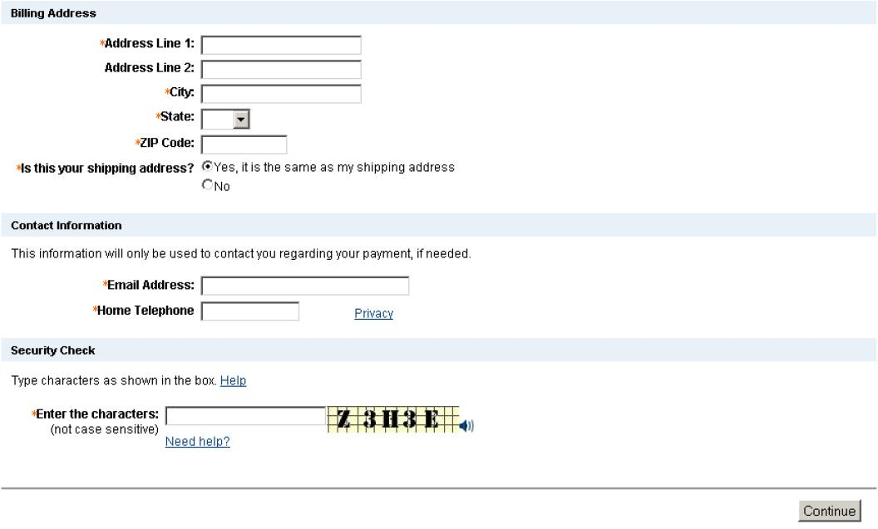
5. Once you click the “Continue” button, you will be shown the screen below where you will verify that all the information is correct. Once you have verified that all the information is correct, click the “Agree and Pay” button on the bottom right side of the page.
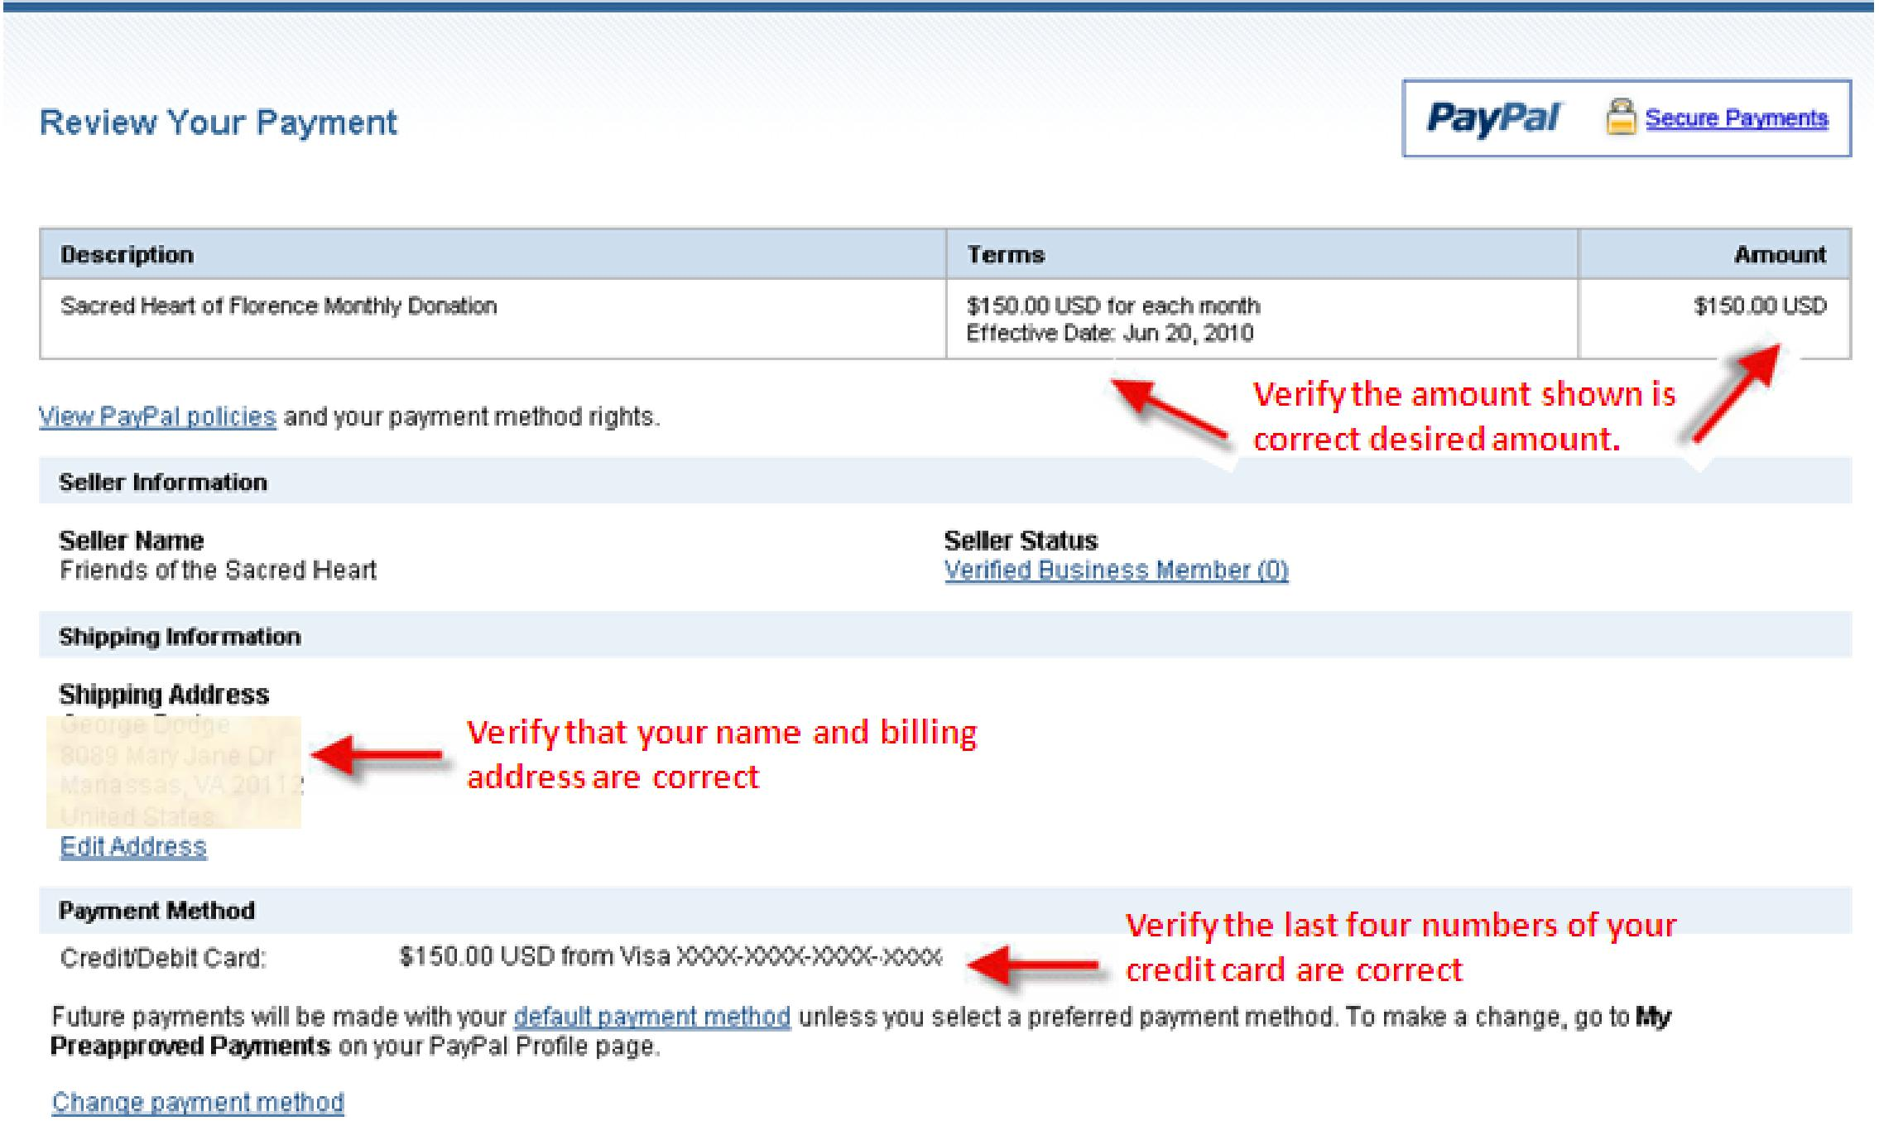

After clicking the “Agree and Pay” button, you will be presented with the screen on the following page.

